|  |  |  |
| --- | --- | --- |
| **Abbreviations** | | |
| **1** | Treatment 1 |  |
| **2** | Treatment 2 |  |
| **3** | Treatment 3 |  |
| **4** | Treatment 4 |  |
| **5** | Treatment 5 |  |
| **6** | Treatment 6 |  |
| **7** | Day 7 |  |
| **13** | Day 13 |  |
| **Tr** | Treatment |  |
| **Sa** | Sample type |  |
| **Da** | Day |  |
|  |  |  |
| **FR** | Feed residue |  |
| **FL** | Fermenter Liquid |  |
| **E** | Effluent |  |
| **SP** | Rumen solid phase | Day 0, Cow 1-3 |
| **RF** | Rumen fluid | Day 0, Cow 1-3 |
| **RF mix** | Rumen fluid | DNA pool / mix buffer |
| **RS mix** | Rumen solid phase | DNA pool |

**Sample number**

|  |  |  |  |  |  |  |  |  |  |  |  |  |  |  |  |  |  |  |
| --- | --- | --- | --- | --- | --- | --- | --- | --- | --- | --- | --- | --- | --- | --- | --- | --- | --- | --- |
|  | **Bacteria** | | | | | | | | | **Archaea** | | | | | | | | |
| **Da/Tr/Sa** | **RS mix** | **RF mix** | **SP** | **RF** | **FR** | **FL** | | **E** | | **RS mix** | **RF mix** | **SP** | **RF** | **FR** | **FL** | | **E** | |
| **-** | **-** | **-** | **-** | **-** | **7** | **13** | **7** | **13** | **-** | **-** | **-** | **-** | **-** | **7** | **13** | **7** | **13** |
| **1** | 2 | 2/1# | 6 | 6 | 8 | 4 | 4 | 4 | 4 | 0 | 0/2# | 3 | 3 | 8 | 4 | 3 | 2 | 2 |
| **2** |  |  |  |  | 8 | 4 | 4 | 4 | 4 |  |  |  |  | 8 | 4 | 2 | 2 | 2 |
| **3** |  |  |  |  | 8 | 4 | 4 | 4 | 4 |  |  |  |  | 8 | 4 | 2 | 2 | 2 |
| **4** |  |  |  |  | 8 | 4 | 4 | 4 | 4 |  |  |  |  | 8 | 4 | 2 | 2 | 2 |
| **5** |  |  |  |  | 7 | 4 | 4 | 4 | 4 |  |  |  |  | 8 | 4 | 2 | 2 | 2 |
| **6** |  |  |  |  | 8 | 4 | 4 | 3 | 4 |  |  |  |  | 8 | 4 | 2 | 2 | 2 |

*Total number of samples from run 1 and 2 and hour 24 and 28 for feed residue samples

#RF mixed with buffer, not DNA mixtures

**Microbiota overall overview**

**BACTERIA**

Figure 1 nMDS plotting sample distribution based on type of samples.

*PERMANOVA table of results*

Unique

Source df SS MS Pseudo-F P(perm) perms

Treatment 5 4022.7 804.55 3.1251 **0.002** 999

Sample type 2 64838 32419 125.93 **0.001** 998

Day 1 3651.2 3651.2 14.182 **0.001** 998

TrxSa 10 3119.4 311.94 1.2117 0.261 999

TrxDa 5 1824.6 364.91 1.4174 0.183 999

SaxDa** 1 667.47 667.47 2.5927 **0.079** 999

TrxSaxDa** 5 966.3 193.26 0.75068 0.674 997

**Statistical significance for type of samples, treatment and day (p-value <0.05), no effect on the combination of all factors.**

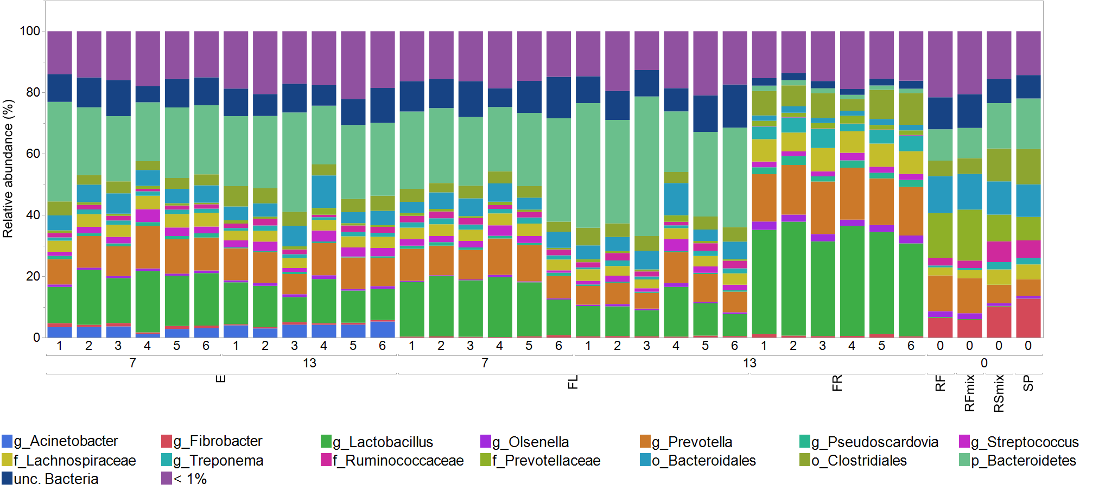

Figure 2 Microbial distribution at genus level across all samples

**Fermenter liquid microbiota**

*PERMANOVA table of results*

Unique

Source df SS MS Pseudo-F P(perm) perms

Treatment 5 3956.5 791.29 2.4837 **0.007** 998

Day 1 2689.3 2689.3 8.4413 **0.003** 999

TrxDa 5 1406 281.2 0.88265 0.573 999

**Permanova analysis revealed effect of the treatment and day (p-value <0.05) no effect on TrXday.**

Figure 3 PCoA plotting the centroids of fermenter liquid samples based on diet and day of sampling.

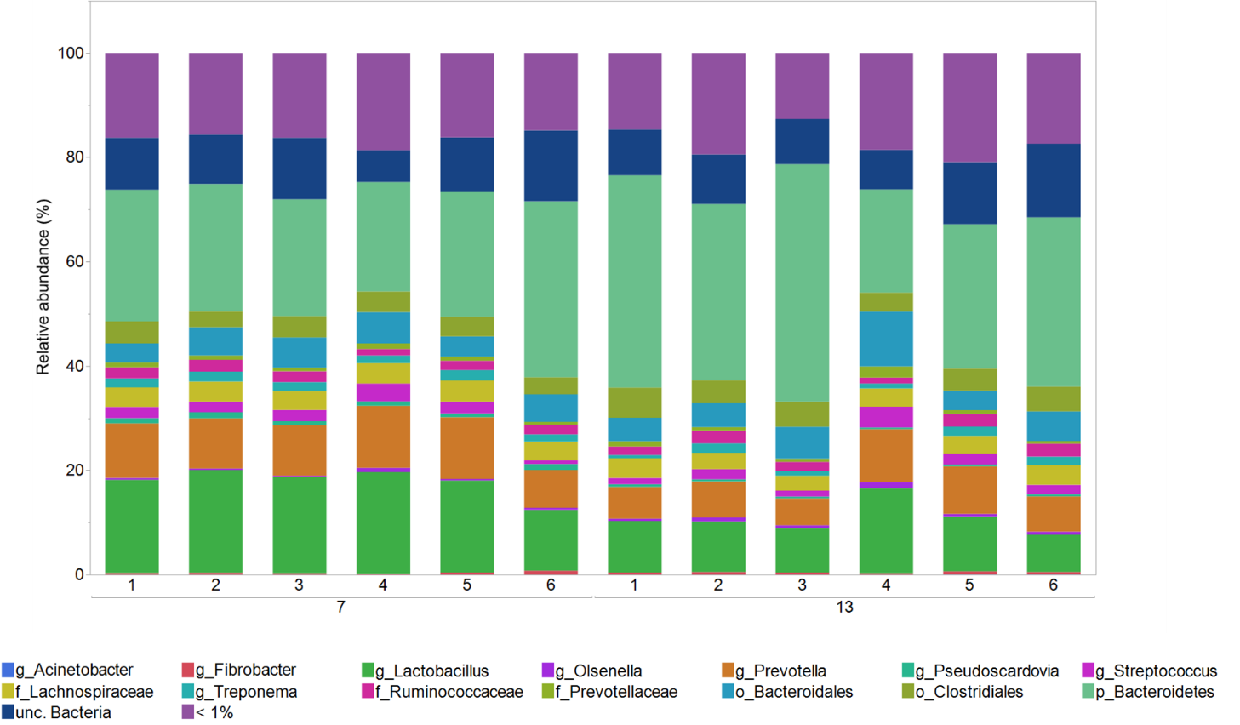

Figure 4 Microbial distribution at genus level across all fermenter liquid samples

**Fermenter liquid microbiota – DAY 7**

Figure 5 nMDS plotting fermenter liquid samples at day 7 based on treatment.

**No statistical significance between the treatments**

**Fermenter liquid microbiota – DAY 13**

Figure 6 nMDS plotting fermenter liquid samples at day 13 based on treatment.

**No statistical significance between the treatments**

**Effluent microbiota**

*PERMANOVA table of results*

Unique

Source df SS MS Pseudo-F P(perm) perms

Treatment 5 2747 549.39 2.1011 **0.017** 999

Day 1 1643.7 1643.7 6.2862 **0.001** 998

TrxDa 5 1398.8 279.75 1.0699 0.387 997

Permanova analysis revealed effect of the treatment and day (p-value <0.05) no effect on TrXday.

Figure 7 PCoA plotting the centroids of effluent samples based on diet and day of sampling.

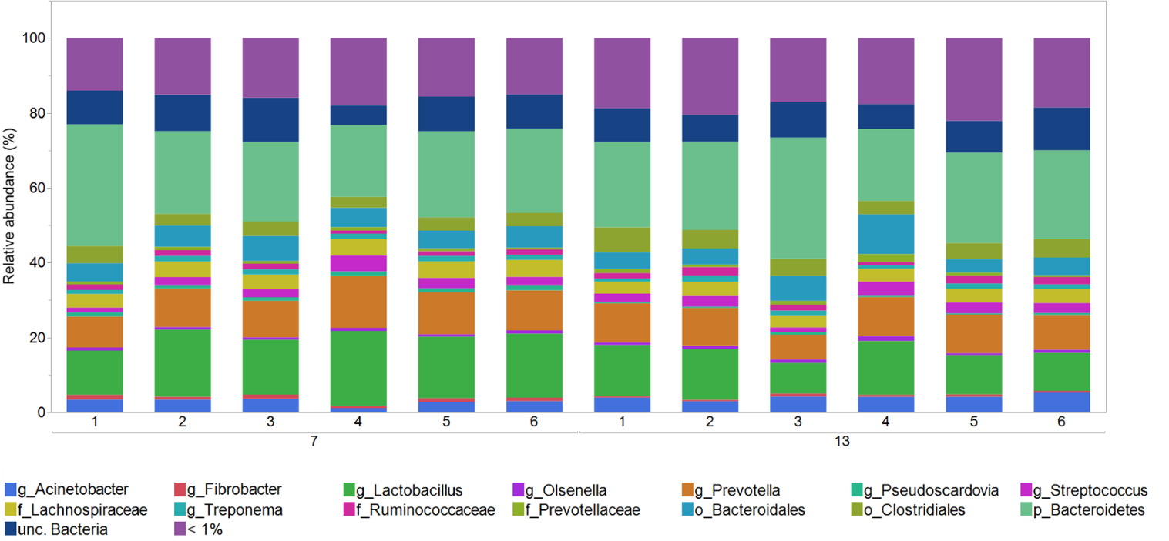

Figure 8 Microbial distribution at genus level across all effluent samples

**Effluent microbiota – DAY 7**

Figure 9 nMDS plotting effluent samples at day 7 based on treatment.

**No statistical significance between the treatments**

**Effluent microbiota – DAY 13**

Figure 10 nMDS plotting effluent samples at day 13 based on treatment.

**Statistical significance between diet 4 and 2 (p-value=0.057), 4 and 5 (p-value=0.057) and 4 and 6 (p-value=0.03).**

**For a better visualization PCoA plot:**

Figure 11 PCoA plotting the centroids of effluent samples at day 13 based on diet

**Feed residue microbiota**

*PERMANOVA table of results*

Unique

Source df SS MS Pseudo-F P(perm) perms

Treatment 5 1678.8 335.77 1.5166 **0.068** 997

Hour 1 62.286 62.286 0.28133 0.948 999

TrxHo 5 405.05 81.01 0.3659 0.999 998

**Permanova analysis revealed effect of the treatment (p-value =0.068) no effect on hour and TrXhour.**

Figure 12 PCoA plotting the centroids of feed residue samples based on diet

**Statistical significance between diet 4 and 1 (p-value=0.013), 2 (p-value=0.025), 3 (p-value=0.01), 5 (p-value=0.003) and 6 (p-value=0.002).**

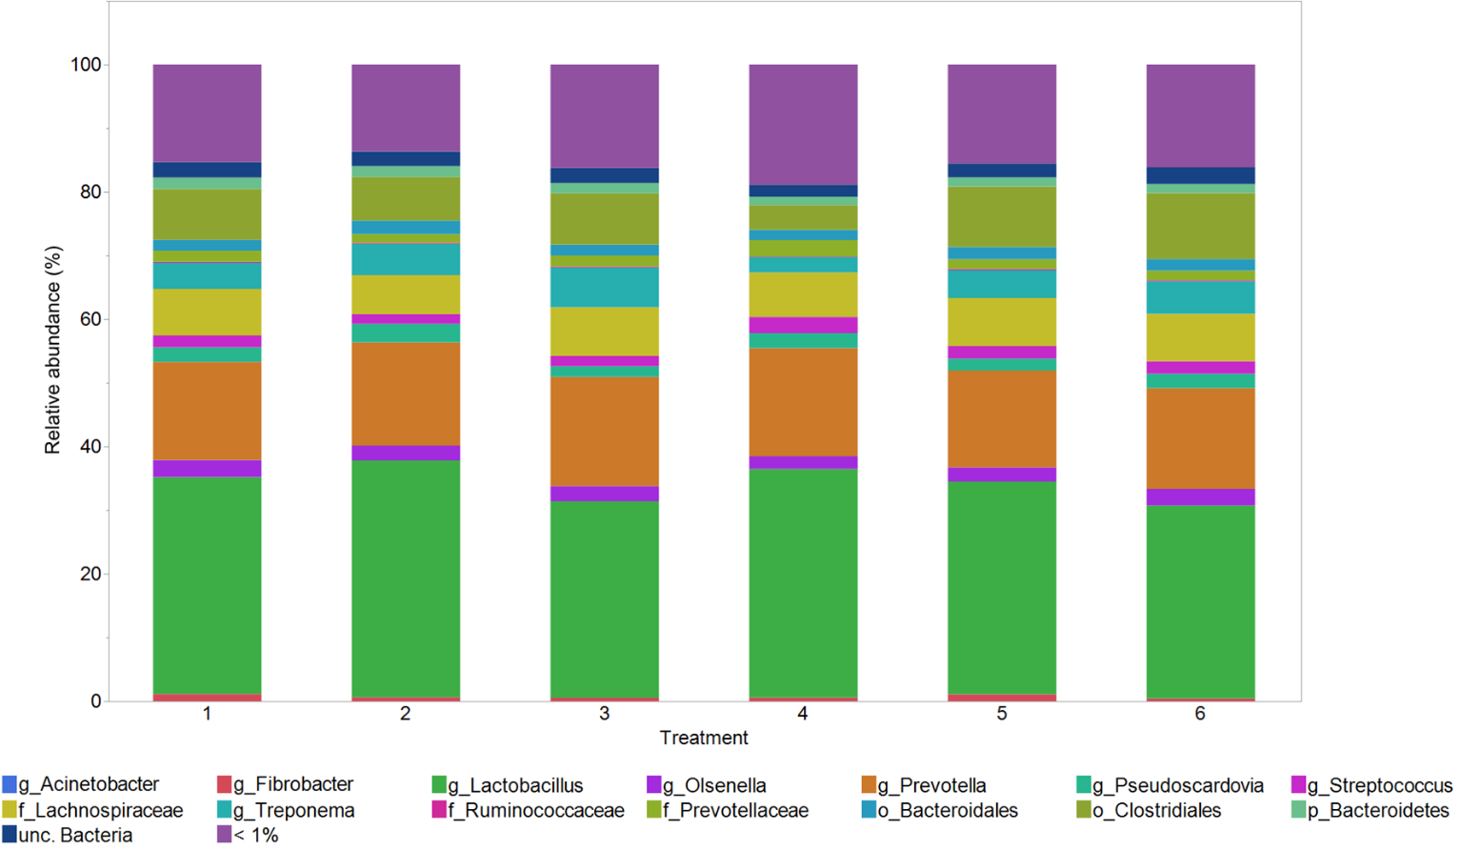

Figure 13 Microbial distribution at genus level across all feed residue samples

**ARCHAEA**



Figure 14 nMDS plotting sample distribution based on type of samples.

*PERMANOVA table of results*

Unique

Source df SS MS Pseudo-F P(perm) perms

Tr 5 13196 2639.2 6.5965 **0.001** 999

Sa 4 6161.8 1540.5 3.8502 **0.001** 999

Da 1 6741.4 6741.4 16.85 **0.001** 999

TrxSa** 10 5360 536 1.3397 0.136 998

TrxDa** 5 11074 2214.8 5.5357 **0.001** 999

SaxDa** 1 423.29 423.29 1.058 0.387 999

TrxSaxDa** 5 508.43 101.69 0.25415 0.995 999

**Statistical significance for type of samples, treatment, day and treatmentXday (p-value <0.05), no effect on the combination of all factors.**

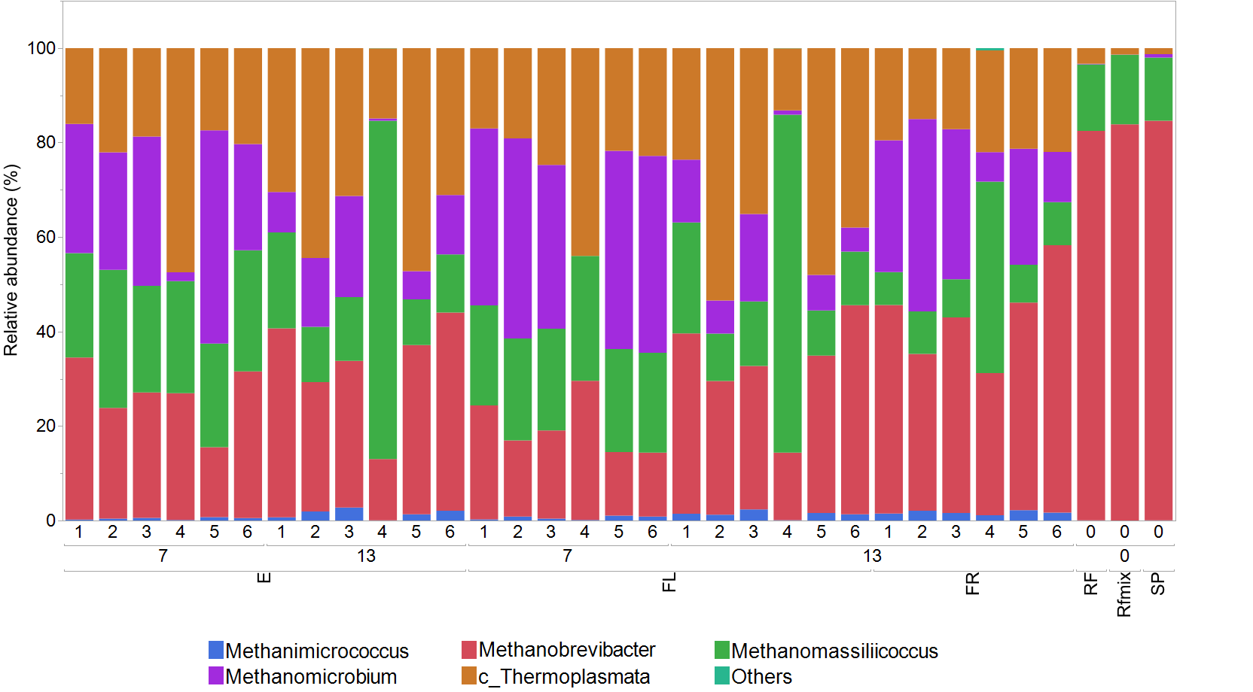

Figure 15 Microbial distribution at genus level across all samples

**Fermenter liquid microbiota**

*PERMANOVA table of results*

Unique

Source df SS MS Pseudo-F P(perm) perms

Tr 5 5972.3 1194.5 4.8381 **0.001** 998

Da 1 5217.1 5217.1 21.131 **0.001** 999

TrxDa 5 7592 1518.4 6.1501 **0.001** 999

**Permanova analysis revealed effect of the treatment, day and treatmentXday (p-value <0.05).**

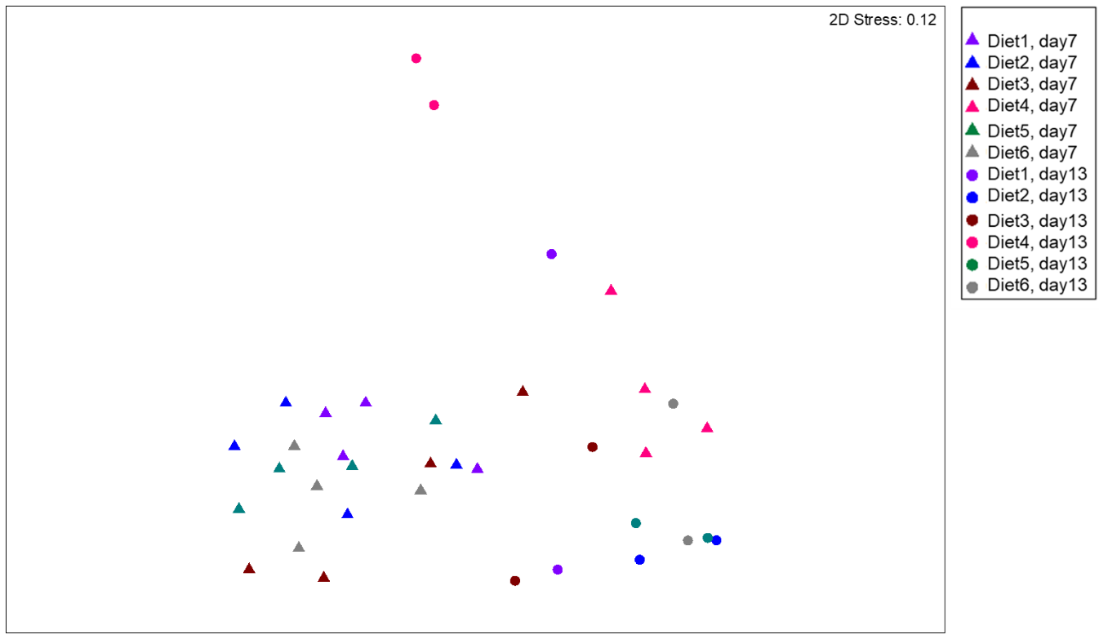

Figure 16 nMDS plotting fermenter liquid samples based on diet and day of sampling.

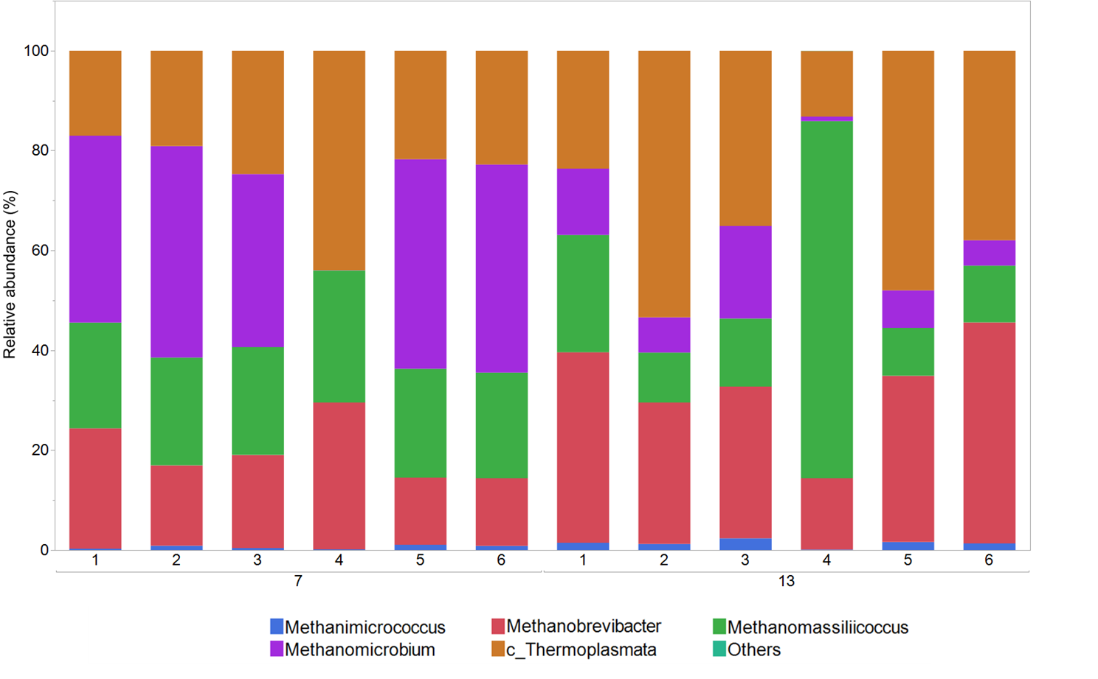

Figure 17 Microbial distribution at genus level across all fermenter liquid samples

**Effluent microbiota**

*PERMANOVA table of results*

Unique

Source df SS MS Pseudo-F P(perm) perms

Tr 5 4048.5 809.7 3.6846 **0.004** 997

Da 1 1928.9 1928.9 8.7774  **0.001** 998

TrxDa 5 4793.1 958.62 4.3623 **0.002** 999

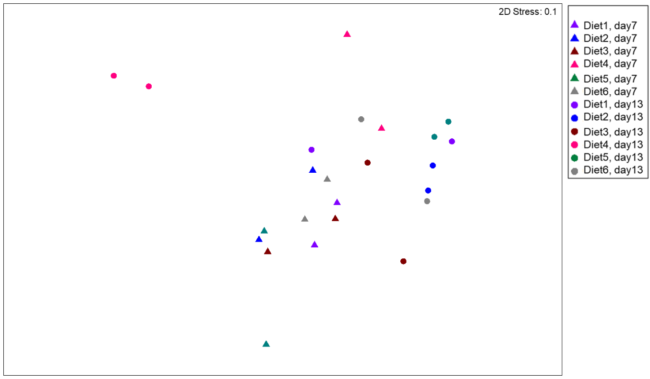

Figure 18 nMDS plotting fermenter liquid samples based on diet and day of sampling

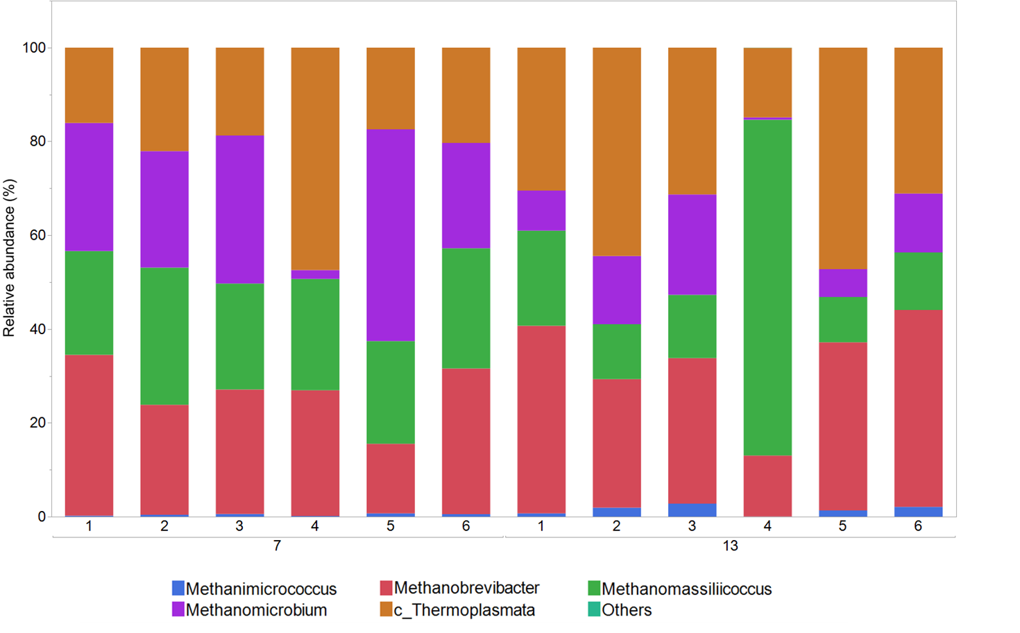

Figure 19 Microbial distribution at genus level across all effluent samples

**Feed residue microbiota**

*PERMANOVA table of results*

Unique

Source df SS MS Pseudo-F P(perm) perms

Tr 5 28355 5671 5.3171 **0.001** 997

Ho 1 467.08 467.08 0.43794 0.796 999

TrxHo 5 3093.2 618.65 0.58004 0.92 998

**Permanova analysis revealed effect of the treatment (p-value =0.068) no effect on hour and TrXhour.**



Figure 20 PCoA plotting the centroids of feed residue samples based on diet

**Statistical significance between diet 4 and all diets (p-value=0.001); diet 2 and 6 (p-value=0.02) and a trend between treatment 3 and 6 (p-value=0.1)**

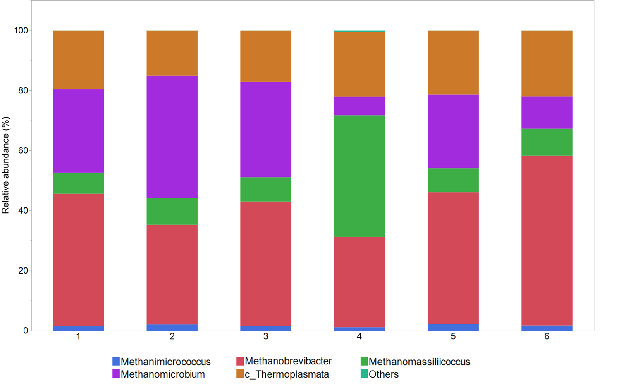

Figure 21 Microbial distribution at genus level across all feed residue sample